Paragraph Writing

1- Pragraph’s Planning:
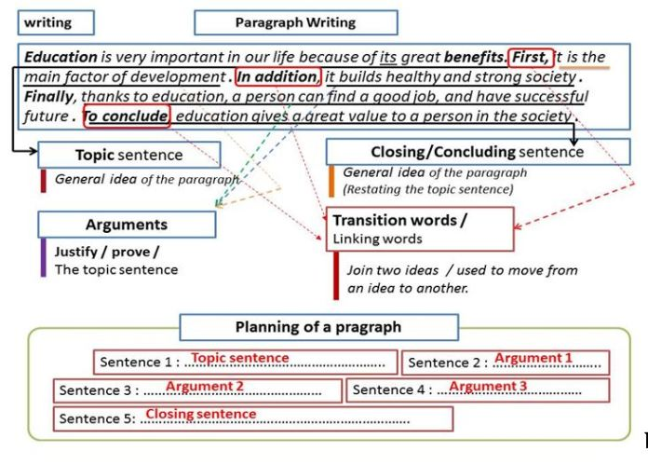

Example : Technology’s advantages
Technology has many advantages. To begin with, it’s making our lives easier and comfortable. In other words, people save more time and effort with the use of technology. For example, machines and robots can perform all of our hard tasks perfectly and in no time. Also, great inventions, like the telephone, computers, the television, the cell-phone, and the internet have made communication easier and better. Additionally, research has confirmed the positive effect of technology on our economic growth. Nowadays, 70% of world businesses rely on technology to improve the quality of their products or services. Moreover, the various technological advances in transportation have turned our world into a small village. This has led to effective interaction between people from different places and cultures. In fact, with all these advantages, technology has brought about many positive changes to our every-day lives.

2-Types of paragraphs and Examples :

a- Argumentative Paragraph:
It presents an opinion on a certain topic and lists a number of reasons, examples, facts, ideas to support it.
Example1 :
Nobody can deny that voluntary work has many benefits . The very first advantage is that it offers help to people in need. In addition, volunteering contributes to the improvement of the community. What’s more, this value helps you reduce stress and boosts your happiness.

Example2 :
I believe that every student should study a foreign language for these reasons. First, knowing a foreign language can help you a lot in life. If you speak more than one language, you have better chances to secure a decent job. Second, your life can be really interesting and exciting when you can talk to people from other countries , read their books, watch their movies.Thirdly, Nowadays, studying English gives one the opportunity to learn about the world and its cultures. Remember that a language is not separate from the people who speak it. When you learn a language you learn more than just words ; in other words ,you learn how other people think and live. In modern times, it’s very important for world peace that we understand one another. Given all these reasons, I think that the world will be a better place if all students have the chance to study a foreign language.

Example 3 :
Although some parents don’t allow their children to watch television, it can be good for them. First of all, I think that television is a cheap entertainment . On Sundays, when children drive their parents crazy, the TV can bring them some fun. Besides this, it is too expensive to take the whole family to the movies. For instance, the family can sit in their living room and watch a movie on television. Secondly, it is my conviction that television can be a good teacher. Studies show that these TV programmes help children do well in school. For example, small children can learn the alphabet and numbers on children’s programmes. In addition to this, nature programmes teach them about our earth and how to care for it. In brief television is a useful medium for the entertainment and teaching of kids.

Example 4:
Nobody denies that using the mobile has many advantages. Firstly, With mobile phones you can communicate with anyone from anywhere at any time. In addition, they have become a source of unlimited entertainment. For example, cell phones allow you to play games, listen to music, watch movies and do a lot of other things. What’s more, Smart phones offer thousands of educational apps. This can be so useful for students in their studies.

b/ Cause-Effect Paragraph :
This type of paragraph discusses the causes and consequences of an action, situation, event, or decision.

Example :
Many causes are behind dropping out of school. Many students leave school because their parents don’t have enough money to teach them. Also, students drop out due to the absence of school transport; they find it difficult to cover a long distance to arrive at school. In addition, because of some parents’ divorce, children no longer feel at ease and they decide to stop schooling. Finally, since the circumstances are hard in the countryside, parents prefer to keep their children at home so as to help them with their work.

c- Narrative Paragraph :
it tells the reader what happened. It relates a sequence of past events using chronological order. It must contain these elements of : – Setting ( time /place) – Point of view – Character – Action .

Example :
Last weekend , I had the best time of my life. On Friday night, my best friend came over and we made a delicious, mouth-watering pizza. After we ate, we had a friendly video game competition. Moments later, my other best friend, Ali, joined us. On Saturday, my dad took us out on the boat. The weather was perfect and the water was warm. It was a great day to go for a swim. Later in the evening , we went to the movies. We saw an action- packed thriller and ate a lot of popcorn. Later that night, we spent some time playing chess. Finally, on Sunday, we went bike-riding around town. By the end of the day, my legs became very sore. We had great moments. I only hope the next weekend can be as fun as this one. Now, with such experience, I’ve changed my opinion about weekends. Now I have to say that weekends can only be as exciting and fun as we would make them to be.

d-Descriptive Paragraph :
In this paragraph, the writer describes a person, a place, or an object.

Example: Describing a person
Song, my best friend, is really a genius. When he first moved to our neighbourhood, the other guys avoided him. But now everybody wants to keep company with him. What is his secret? He is a brainy boy! He can solve mathematical operations faster than a calculator, and he can memorise things better than any of his peers. He always gets the best grades at school1 and he is highly acclaimed by teachers. What makes him even more popular is his being modest, sociable and reliable. Although he is the shortest boy in our group, he is a gifted basketball player. Physically, he is round-faced, pale looking with brown small eyes and short straight hair. He is usually dressed in casual clothes: tight jeans and T-shirts. All those who know him, including classmates and teachers, believe Song possesses the traits of a genius.

